MIT REMOTE REARCH ON BIG DATA

RAN TONG

Overall description
Big data represents the information assets characterized by such a high volume, velocity and variety to require specific technology and analytical methods for its transformation into value.This project aims to get the participants famliar with the cutting edge big data technology such as container,Docker,Cassandra,Spark etc.
This project is consisted of several aims:
To deploy a digit handwriting program based on MNIST via Flask.We can get access to this program using docker. At the exact same time,the result and the time could be recorded into Cassandra.

Mnist

The MNIST database of handwritten digits has a training set of 60,000 examples, and a test set of 10,000 examples. It is a subset of a larger set available from NIST. The digits have been size-normalized .
Each picture in the MNIST dataset is 28 * 28 pixels in size, and an array of 28 * 28 can be used to represent a picture.

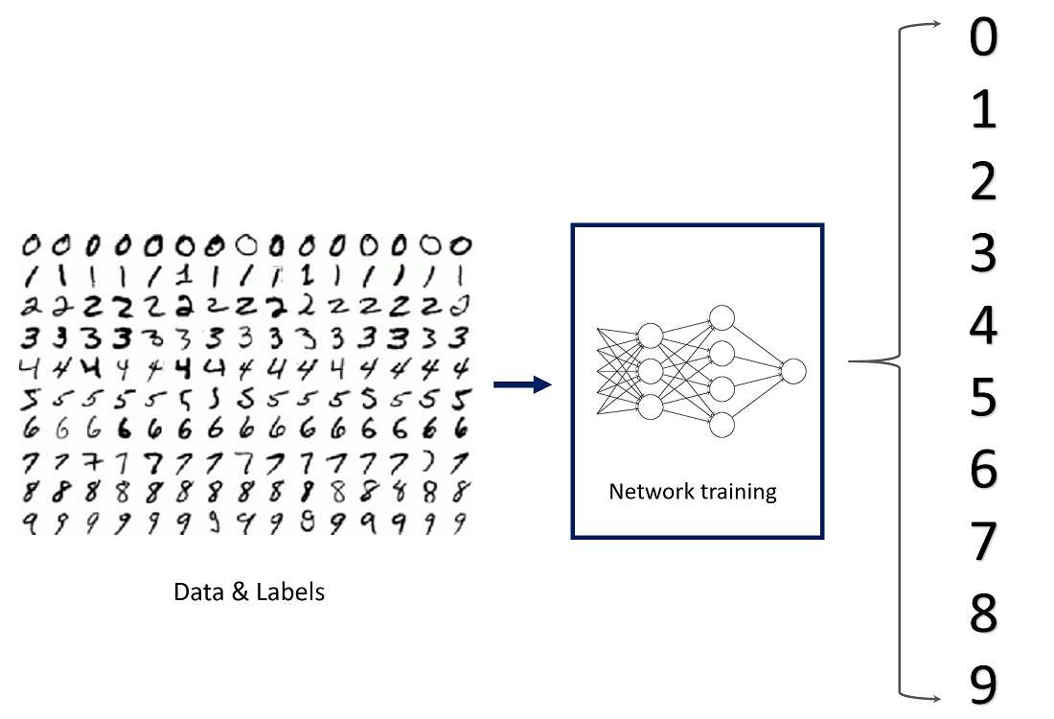
In this program,we could consider using the following code:

The first is a simple but well defined mnist program:
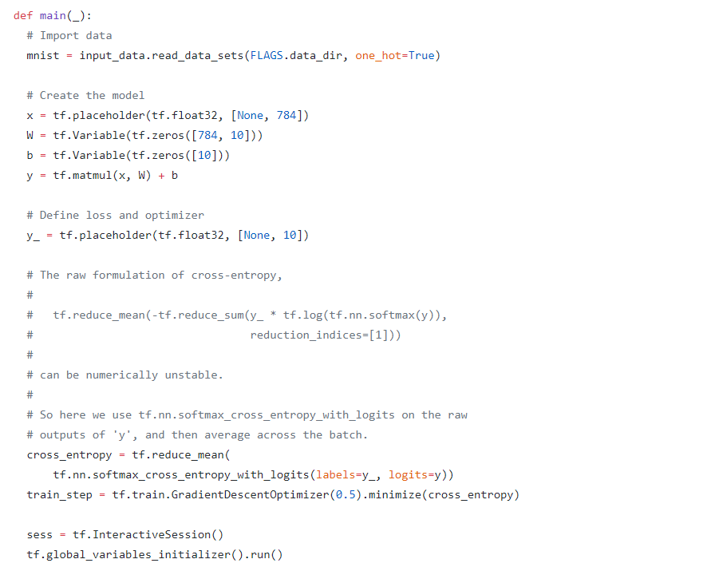

We could also build a neural network ,
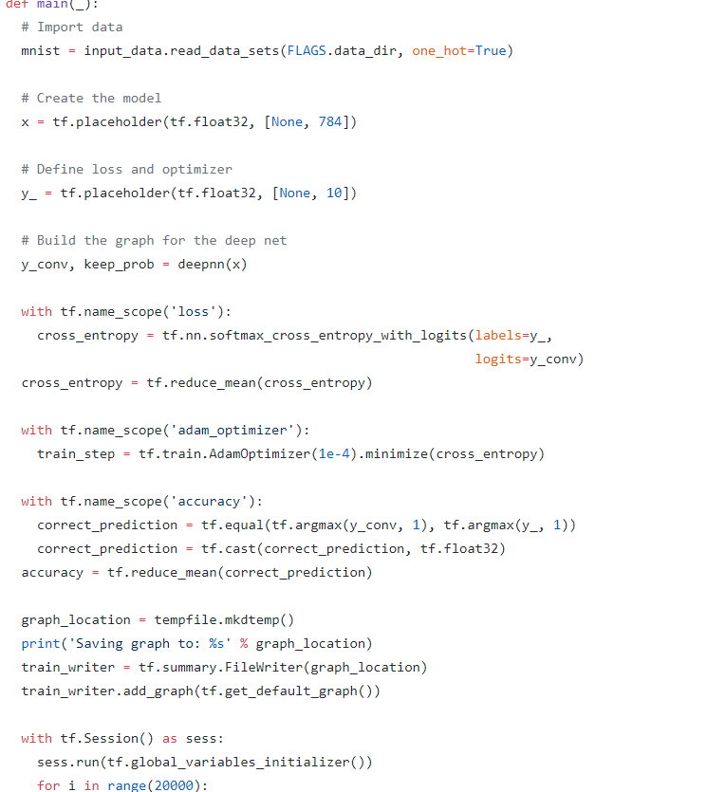

In which :
Input x: Input refers to the vector passed into the network, which is equivalent to the variable in the mathematical function.
Output Y: Output refers to the result returned after network processing, which is equivalent to the function value in the data function.
Label: Labels refer to the results we expect the network to return.
For MNIST image recognition, the input is a vector of 784 (28 * 28) size, and the output is a probability vector of 10 size (the position with the highest probability, i.e. the predicted number).
We can choose one of them .(the latter may consume more time)

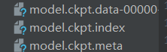
We need to train our the model we applied with the mnist dataset,and save results :

WE save teh model as ckpt.And what we are going to do next is to integrate it with flask.

Flask
Flask is a web application framework written in python.. It is classified as
a microframework because it does not require particular tools or
libraries. It has no database abstraction layer, form validation, or any
other components where pre-existing third-party libraries provide
common functions.In this project, I use flask to deploy the application.

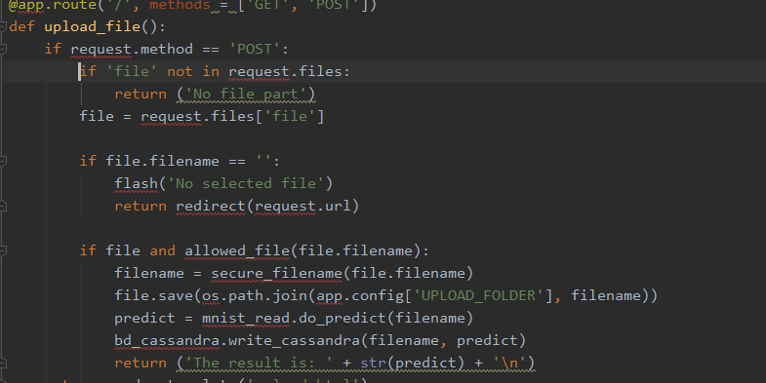
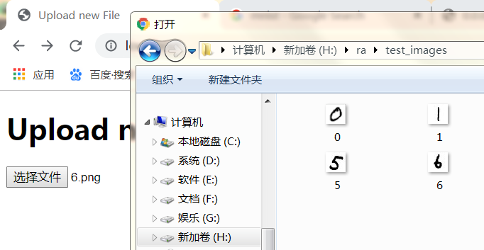
We can upload the pictures that we have prepared.The router will save the image and requests ,and the resuilt will return to the browser after calling the model.All of this will be done in local host.

Docker
A quite significant tool I have got to known in this project is docker.Docker is mainly a software development platform and a kind of virtualization technology that makes it easy for us to develop and deploy apps inside of neatly packaged virtual containerized
environments.To be specific, it is just like running on a virtue machine without those we do not need at all ,that will definitely save a lot of space and calculation time. What is more,Docker's interface is fairly simple. Users can easily create and use containers and put their applications in containers. Containers can also be
versioned, copied, shared, and modified, just like ordinary code.
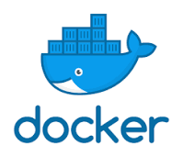

Cassandra
Cassandra is a free and open-source, distributed, wide column store, NoSQL database management system designed to handle large amounts of data across many commodity servers, providing high availability with no single point of failure. Cassandra offers robust support for clusters spanning multiple datacenters,with asynchronous masterless replication allowing low latency operations for all clients.

In this project, we need to create a docker network for the communication between the two containers: by using
docker network create (name)
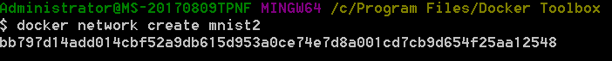

And then we need to create the container to hold the application we have made by:
docker build -t [image]:latest

Since we use cassandra driver ,thus we need to define keyspace first:

And then,we need to define teh table:
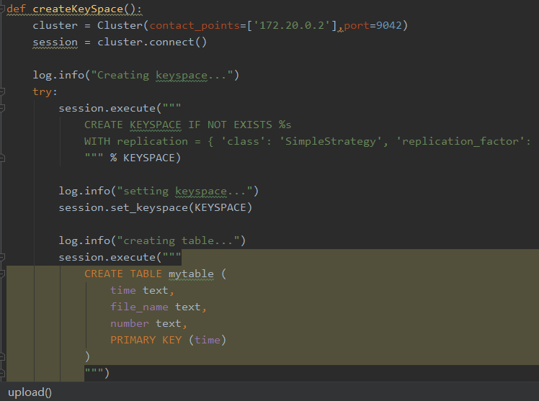

Insert the data:
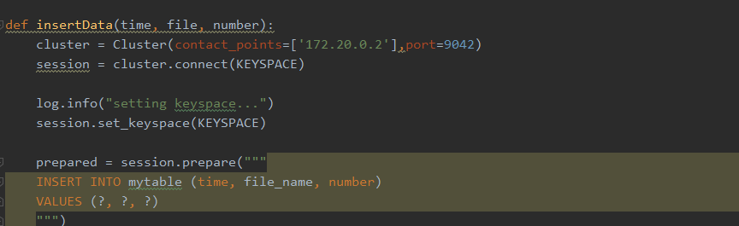

The code work is done here.

How to run this part :
So in this project,we need to pull the cassandra image from the Docker Hub first,using the following code in docker toolbox:
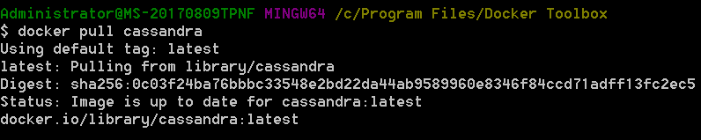

We need to construct the Docker network bridge in order to link the containers with each other by using:

We also need a container to hold the image of Cassandra we have pulled before.

We could check the status by using docker ps:
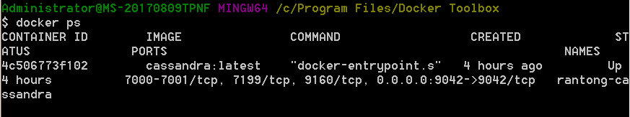

Then we need to build the application image from the Dockerfile by using:

docker build -t mnist:latest .

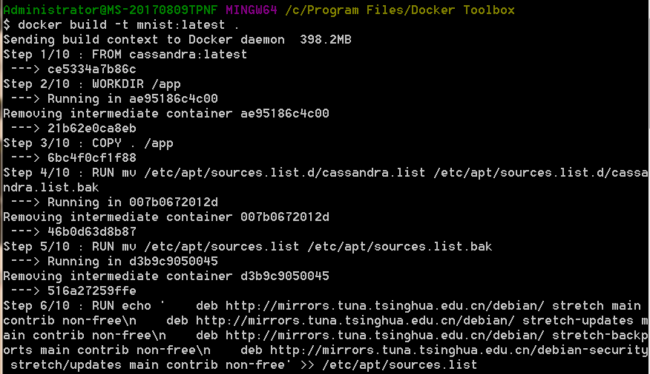
It goes well first,but i got a problem here
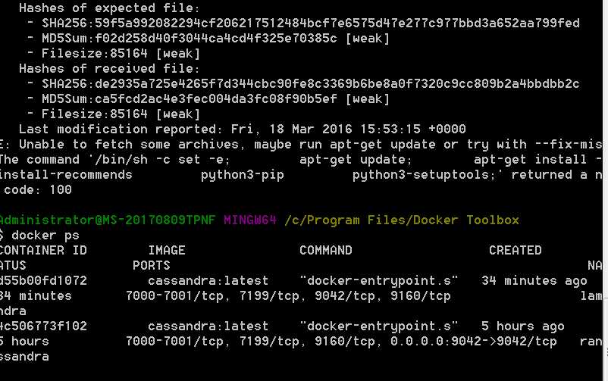
.
We can proceed to running the following to run the container if there is nothing wrong.
docker run -p 5000:5000 mnist:latest
And call shell:
docker exec -it mnist_cassandra cqlsh .

..So currently I got stuck at this step.If there is any progress,i will update it.This problem could be caused because there is something wrong with the dockerfile,which needs to be checked thorougly.

Conclusion
Though the project is still in progress,and I haven’t achieved the ultimate goal ,I will keep working on that.I hope I can harness the tools that were introduced in the classes given that they are becoming the new trend of big data techniques.

